**­­**

**FINALyze**

**Project Plan**

**Document Control**

Document Information

|  |  |
| --- | --- |
| **©** | **Information** |
| Document Id | *Finalyze_PP* |
| Document Owner | *Mohammed Aiman Khan* |
| Issue Date | *4th Feb 2025* |
| Last Saved Date | *6th Feb 2025* |
| File Name | *Finalyze_project_plan* |

Document History

|  |  |  |
| --- | --- | --- |
| **Version** | **Issue Date** | **Changes** |
| *1.0* | *4-02-2025* | *Initial* |
| 1.01 | 6-02-2025 | Work in progress |
|  |  |  |
|  |  |  |

Document Approvals

|  |  |  |  |
| --- | --- | --- | --- |
| **Role** | **Name** | **Signature©** | **Date** |
| Project Sponsor | <name> |  |  |
| Project Review Group | <name> |  |  |
| Project Manager | <name> |  |  |
| Quality Manager  *(if applicable)* | <name> |  |  |
| Procurement Manager  *(if applicable)* | <name> |  |  |
| Communications Manager  *(if applicable)* | <name> |  |  |
| Project Office Manager  *(if applicable)* | <name> |  |  |

## Project Purpose, Goals and Objectives

|  |  |
| --- | --- |
| **Project Purpose** | |
|  | |
| **Project Goal** | **Project Objectives** |
| Goal 1 | To create a user specific web app and analysing the Return on Investment for user for each product |
|  |
|  |
| Goal 2 | to calculate gross & net margin for product |
|  |
|  |
| Goal 3 | analysing the Return on Investment for user for each product |
|  |
|  |

## Project Success Criteria

Determine what will make this project successful. These standards vary based on the project, but they typically include considerations like time, cost and scope. Additional criteria considerations include quality, risk management, stakeholder satisfaction, business value, regulatory compliance and customer satisfaction, to name a few.

|  |  |  |  |  |
| --- | --- | --- | --- | --- |
| **Category** | **Success Metric** | **Measurement Method** | **Target** | **Assigned to** |
| Scope | Requirement Completion % | Story point planned vs completed | >75% | Mohammed Aiman Khan |
| Schedule | Schedule Variance | Planned Scheduled – Actual schedule | <10% | Mohammed Aiman Khan |
| Budget | NA | NA | NA | NA |
| Quality | Defect rate | Defects / story point | 0 major  2 minor | Mohammed Aiman Khan |
| Stakeholder satisfaction |  |  |  |  |
| Risk management | % of risk mitigated | Risk mitigated / total risk weightage % | Improving week on week | Mohammed Aiman Khan |
| Resource utilization | NA | NA | NA | NA |
| Compliance | NA | NA | NA | NA |

## Project Team

|  |  |  |
| --- | --- | --- |
| **Name** | **Role** | **Responsibilities** |
| Mohammed Aiman Khan | Team Lead | Prepare technology stack Layout development life cycle |
| Mohammed Aiman Khan | Developer | Code and unit test |
| Mohammed Aiman Khan | Tester | Integration Testing |

## Project Governance.

|  |  |  |
| --- | --- | --- |
| **Area** | **Description** | **Responsible Party/Role** |
| Steering Committee |  |  |
| Change Control Board | User, management and project manager to follow the change control document | Project manager |
| Compliance Auditing | NA | NA |
| Stakeholder Communication | Weekly progress report will be shared to management | Project Manager |
| Performance Reviews | Project manager will review the teams progress | Project Manager and Team |
| Project Closure Review | Management team will review the clouser report with end user representative and project manager | Management team, project team and end users |

## Stakeholder Management Plan

A stakeholder management plan helps manage stakeholder expectations and address any concerns they may have. It includes the following sections.

* **Stakeholder Register:** This document lists all individuals or groups who may have an interest in a project.

|  |  |  |  |  |
| --- | --- | --- | --- | --- |
| **Name** | **Role** | **Power** | **Interest** | **Contact information** |
| **DEEPIKA J** | **Project Director** | **High** | **High** | **20163 - SCOPE** |
| **Mohammed Aiman Khan** | **Project Manager** | **High** | **High** | **aimanmrkhan@gmail.com** |
| **Mohammed Aiman Khan** | **Architect** | **Medium** | **High** | [**aimanmrkhan@gmail.com**](mailto:aimanmrkhan@gmail.com) |
| **Mohammed Aiman Khan** | **Developer** | **Low** | **Medium** | [**aimanmrkhan@gmail.com**](mailto:aimanmrkhan@gmail.com) |
| **Mohammed Aiman Khan** | **Tester** | **Low** | **Low** | [**aimanmrkhan@gmail.com**](mailto:aimanmrkhan@gmail.com) |
| **Mohammed Aiman Khan** | **Deployer** | **Low** | **Low** | **aimanmrkhan@gmail.com** |

* **Stakeholder Map:** This visually represents the groups or individuals with a vested interest in the project and helps develop a strategy for stakeholder management.

|  |  |  |  |  |  |  |  |  |
| --- | --- | --- | --- | --- | --- | --- | --- | --- |
| Level of Influence |  | Keep Satisfied | | | | | Manage Closely | |
| High |  | | Project Director | | |  | |
| Medium |  | |  | | | **Architect** | |
| Low |  | |  | | | Developer, Tester, Deployer | |
|  | Monitor | | | | | Keep Informed | |
|  | Low | | | Medium |  | | High |
|  |  | | Level of Interest | | | | | |

* **Stakeholder Engagement Strategies:** List some effective stakeholder engagement strategies including communication style, involvement and participation, relationship building and conflict and resolution.

|  |  |  |
| --- | --- | --- |
| **Engagement Activity** | **Who** | **Duration** |
| Weekly Report | Project Director | Weekly |
| Daily Progress Check | Developer, Tester | Daily |
| Deployment Review | Deployer | 2 days once |
| Bi-Weekly Progress | Architect | 2 times weekly |

## Scope Management Plan

Begin with the project scope. What activities and tasks as defined in your project must be completed to make the project a success? Use the project charter as a springboard. You can also use a work breakdown structure to identify all the activities, tasks, deliverables and milestones of your project.

‘Dependencies’ are logical relationships between phases, activities or tasks which influence the way that the project must be undertaken. Dependencies may be either internal to the project (e.g. between project activities) or external to the project (e.g. a dependency between a project activity and a business activity).

There are four types of dependencies:

1. Finish-to-start *(the item this activity depends on must finish before this activity can start)*
2. Finish-to-finish *(the item this activity depends on must finish before this activity can finish)*
3. Start-to-start *(the item this activity depends on must start before this activity can start)*
4. Start-to-finish *(the item this activity depends on must start before this activity can finish).*

|  |  |  |  |
| --- | --- | --- | --- |
| Scope Baseline | | | |
| **Task** | **Dependencies** | **Deliverables** | **Acceptance Criteria** |
| User Registration Screen | None | Screen | Creates new user |
| User Login Screen | **Finish-to-Start**  User Registration Screen | Screen | Login user into app |
| User Logout Screen | **Finish-to-Start**  User Login Screen | Control Transfer | Process control back to main screen |
| Margin and ROI calculation screen | **Finish-to-Start**  User Login Screen  **Finish-to-Finish**  Calculations Process | Screen | Correct Margin and ROI calculation display |
| Calculations Process | **Start-to-Start**  Margin and ROI calculation screen | Procedure | Correct Margin and ROI calculation |
| Report | **Finish-to-Start**  Calculations Process | Screen | Correct data display |

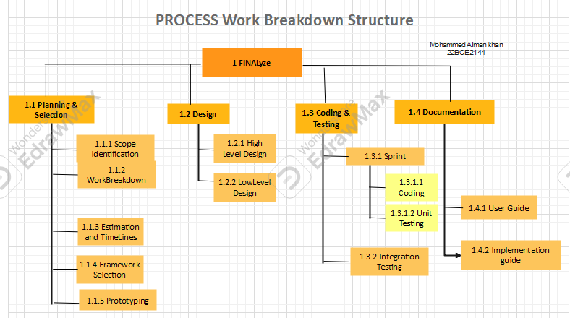

|  |  |
| --- | --- |
| Exclusions, Assumptions and Constraints | |
| **Exclusions** | * Master data Management * Data Analysis * AI and suggestions * Hosting * Mobile and Tablet app   Project Costing  Communication details  Scalability and portability |
| **Assumptions** | * Assume a widely used MVC framework will be selected as skill and resources are freely available * Development will be done on local host and no hosting is in scope * Master data of product and business is not taken into scope * Scalability and Security are not in scope * Dependency is on framework finalization. |
| **Constraints** | * Need to have a working prototype by mid-march and this semester being only 3 working months. * Resource limitation – knowledge limitation based on framework finalized |

|  |  |  |
| --- | --- | --- |
| Milestone | Description | Delivery Date |
| 1 | Requirement Gathering | 28-01-25 |
| 2 | H/W and S/W finalization | 29-01-25 |
| 3 | Framework Finalization | 07-02-25 |
| 4 | HLD | 13-02-25 |
| 5 | LLD | 21-02025 |
| 6 | UI and Process Completion | 21-03-25 |
| 7 | Acceptance Testing | 24-03-25 |
| 8 | Project Clouser | 25-03-25 |

## Resource Requirements

For each task identified, list the resources allocated to complete the task.

|  |  |  |
| --- | --- | --- |
| **Task** | **Resource requirements** |  |
| Project Planning | Project Manager | |
| Project Designing | Architect | |
| Project Development | Developer, Tester and Deployer | |

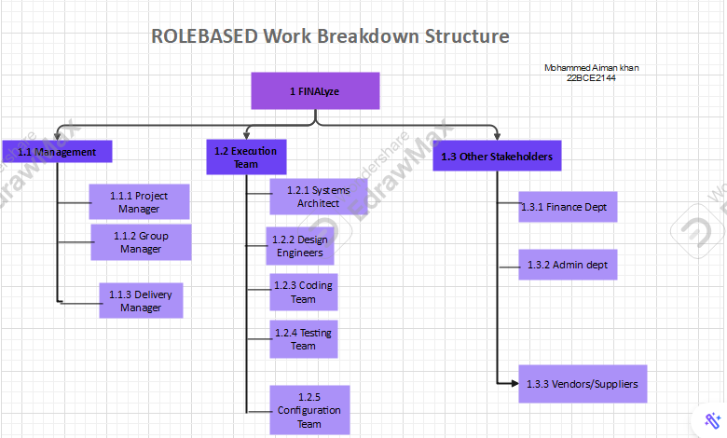

## Project Schedule

The project schedule indicates when the project tasks defined in the scope management section will be executed, including task dependencies, milestones and key deliverables.

The image below shows a Gantt chart, which is the perfect project management tool to easily visualize these and other details of the project schedule, such as the critical path of the project.

**Estimation:**

|  |  |  |  |
| --- | --- | --- | --- |
| **Bottom-Up Approach Estimation** | | | |
| **Activities** | **Days** | **hrs/day** | **Effort (hrs)** |
| Requirement gathering | 7 | 2 | 14 |
| H/W & S/W Req | 10 | 1 | 10 |
| PLANNING | 16 | 0.25 | 4 |
| FRAMEWORK SELECTION | 5 | 2 | 10 |
| HIGH LEVEL DESIGN | 8 | 0.5 | 4 |
| LOW LEVEL DESIGN | 9 | 0.75 | 6.75 |
| CODING | 25 | 1 | 25 |
| UNIT TESTING | 22 | 0.25 | 5.5 |
| INTEGRATION | 10 | 0.5 | 5 |
| CONFIGURATION Mgmt | 30 | 0.1 | 3 |
| FINAL DEMO | 1 | 2 | 2 |
| FEEDBACK | 1 | 5 | 5 |
| CLOUSER | 1 | 5 | 5 |
| TOTAL HOURS |  |  | **99.25** |
| MAN DAYS (4hrs = 1md) |  |  | **24.8125** |

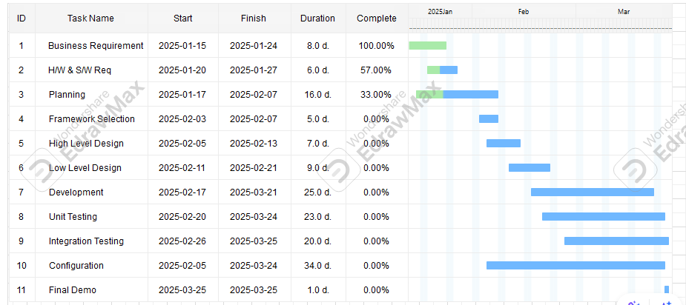

## SPRINT Plan

how much the labor and materials necessary to execute it will cost. Then add your budget to the appropriate column and the

## Project Budget

List the task and how much the labor and materials necessary to execute it will cost. Then add your budget to the appropriate column and the actual spend to the next column to track planned costs against actual costs.

|  |  |  |  |  |  |
| --- | --- | --- | --- | --- | --- |
| **Task** | **Labor Costs** | **Material Costs** | **Other Costs** | **Budget** | **Actual** |
|  |  |  |  |  |  |
|  |  |  |  |  |  |
|  |  |  |  |  |  |
|  |  |  |  |  |  |

## Cost Management Plan

Another important part of a project management plan template is a cost management plan. It describes the processes and procedures that will help plan, es timate, budget and control project costs.

**Cost Estimation Methodology**

* Analogous Estimating
* Parametric Estimating

**NOT IN SCOPE**

* Bottom-Up Estimating
* Three-Point Estimating

**Cost Control Tools and Techniques**

* Earned value management (EVM)
* Variance Analysis
* Trend Analysis
* Cost Baseline Tracking
* Cash flow management
* Cost Reports
* Cost re-baselining

**Cash Flow Projections**

|  |  |  |  |  |
| --- | --- | --- | --- | --- |
| Time Period | Projected Cash Inflows | Projected Cash Outflows | Net Cash Flow | Cumulative Cash Flow |
|  |  |  |  |  |
|  |  |  |  |  |
|  |  |  |  |  |

## Change Management Plan

When a change request is made, use this log to track its impact, response and whether the change control board has approved it or not.

**Change Control Board**

|  |  |  |
| --- | --- | --- |
| **Name** | **Role** | **Responsibilities** |
|  |  |  |
|  |  |  |
|  |  |  |

**Change Order Request Form**

**Change Log**

|  |  |  |  |  |  |
| --- | --- | --- | --- | --- | --- |
| Date Identified | Request | Impact | Approval | Date Started | Date Completed |
|  |  |  |  |  |  |
|  |  |  |  |  |  |
|  |  |  |  |  |  |

## Risk Management Plan

Every project plan template needs a risk management plan. This is a section that identifies any potential risks that might affect the project plan, prioritizes them, defines risk mitigation activities and establishes the roles and responsibilities of the team.

* **Risk Matrix:** A risk matrix is a visual representation of the potential project risks based on their likelihood and impact. It makes it easy to see what risks are pressing and what risks likely won’t come to fruition.

|  |  |  |  |  |  |  |
| --- | --- | --- | --- | --- | --- | --- |
| **Risk Matrix** | | **Severity** | | | | |
|
| Insignificant | Minor | Moderate | Major | Severe |
|
| **Likelihood** | Almost Certain | Medium | High | Very High | Very High | Very High |
|
| Likely | Medium | High | High | Very High | Very High |
|
| Possible | Low | Medium | High | High | Very High |
|
| Unlikely | Low | Low | Medium | Medium | High |
|
| Rare | Low | Low | Low | Low | Medium |
|

* **Risk Log:** Our project plan template has a risk log so you can list the potential risks that could affect your project plan. From there you can develop your risk mitigation strategies and assign risk owners.

|  |  |  |  |  |  |
| --- | --- | --- | --- | --- | --- |
| Risk | Likelihood | Impact | Response | Risk Level | Risk Owner |
| Framework selection | High | High | Work in progress | High | Mohammed aiman khan |
| Less time | High | High | Work in progress | High | Mohammed aiman khan |
|  |  |  |  |  |  |
|  |  |  |  |  |  |

* **Risk Mitigation Strategies:** Various techniques can be used to reduce the impact or likelihood of a risk occurring. Some examples include risk reduction, risk avoidance or risk acceptance.
* **Assumptions and Constraints:** List any assumptions you have about the project. Then note the project constraints. Finally, in an appendix, you’ll want to attach the supporting documentation, such as the project schedule, business case, feasibility study, project charter, etc.

## Quality Management Plan

We also include a quality management plan in our project plan template. It’s made up of the following parts.

* **Quality Standards:** These are the criteria and benchmarks that measure the quality of a project’s processes and deliverables. They enable the project to meet stakeholder expectations.
* **Quality Assurance Guidelines:** Next are quality assurance guidelines that help define quality standards and establish quality control procedures. These guidelines can help improve customer and stakeholder satisfaction.
* **Quality Control Procedures:** List the specific actions that you’ll take to ensure the product, service or process meets the predetermined quality standards.

|  |  |  |  |
| --- | --- | --- | --- |
| Task or Deliverable | Quality Standards | Quality Assurance Guidelines | Quality Control Procedures |
| Project plan | Good | Good | good |
| SRS | Good | Good | good |
| Requirements | Good | Good | good |
| Flow and State diagrams | Good | Good | good |
| HLD |  |  |  |
| LLD |  |  |  |
| Framework selection |  |  |  |
| Prototype |  |  |  |
| Code |  |  |  |
| Test cases |  |  |  |
| Test results |  |  |  |
| Deployment document |  |  |  |

## Procurement Management Plan

In the procurement management plan section of the template, you’ll outline the strategies and processes for acquiring external sources for a project.

* **Vendor selection process:** What vendors are the best fit for the job? To select the right vendor, define the project requirements, evaluate proposals, conduct interviews and negotiate contracts.
* **Procurement schedule:** This is a detailed timeline that outlines the deadlines, responsibilities and activities that will take place during the procurement process.

## Project Communication Plan

Last but certainly not least in the project planning template is the project communication plan. This is an opportunity to outline key communication facets that will be present throughout the project.

* **Project Reports & Reporting Frequency:** Weekly to project management
* **Project Meetings:** Weekly with project owner
* **Project Documentation:** Git Hub

## Appendix

Attach any documentation you believe is relevant to the Project Plan. For example:

* Detailed Project Schedule (listing all project phases, activities and tasks)
* Other documentation (Business Case, Feasibility Study, Project Charter)
* Other relevant information or correspondence.